Lab04 report by 9817059李揚 (Eric L. Lee)

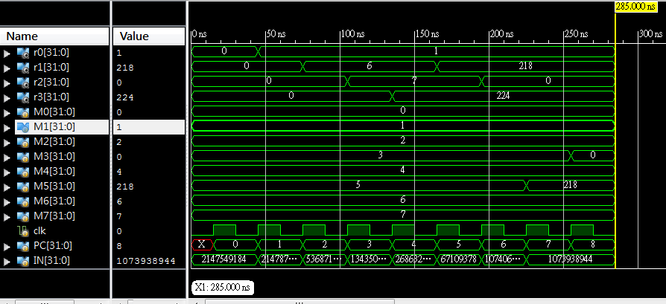

0 LOAD M1 R0: The instruction will put value 1(the value of M1) to R0(the first change of the r0 signal)

1 LOAD M6 R1: The instruction will put value 6 to R1;(the first change of the r1 signal)

2 ADD R0 R1 R2: R2<-R0+R1; R2<-7;(the first change of the r2 signal)

3 SL R2 5 R3: R3<-R2*2^5(R3=7*32=224)(the first change of the r3 signal)

4 SUB R3 R1 R1: R1<-R3-R1(R1=224-6=218)(the second change of the r1 signal)

5 SR R0 2 R2: R2<-R0/4=0(the second change of the r2 signal)

6 STORE M5 R1: Let M5 be R1(so M5=218 now)(the first change of the M5 signal)

7 STORE M3 R2: Let M3 be R2(so M2=0 now)(the first change of the M3 signal)

So the final result is

R0:1 R1:218 R2:0 R3:224

M0:0 M1:1 M2:2 M3:0 M4:4 M5:218 M6:6 M7:7

which is the same as the answer.

Data Path(the next page): 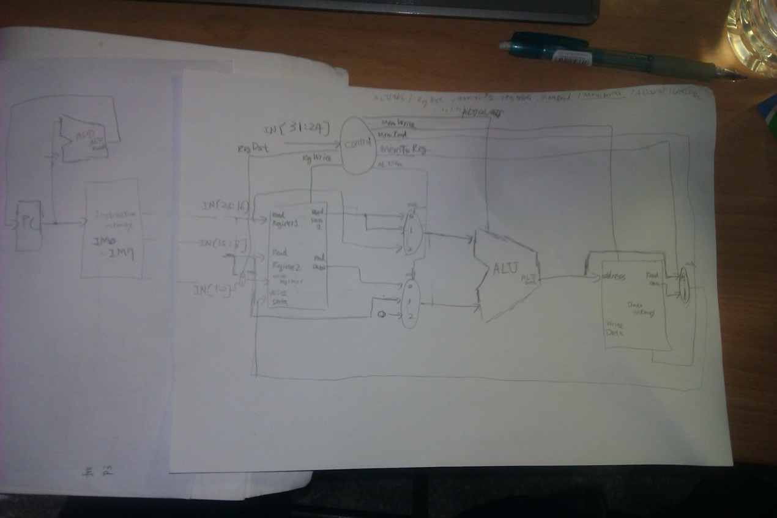

Reflection:

Actually, the code is almost the same as LAB3. The design of LAB3 is already a single cycle ALU. I only modify the TESTBED and read the instruction into the instruction memory IM0~IM7. And then, I use a PC for program counter to indicate which instruction I want to execute now.

And I learn how to write TESTBED through this lab. Actually, it is my first time to write TESTBED. So, it costs me a lot of time to learn how to write TESTBED in this lab. I think I learn a lot of instructions which is used in TESTBED. I hope I can be more and more familiar with it in the future.

|  |  |
| --- | --- |
|  |  |
|  |  |
|  |  |
|  |  |
|  |  |
|  |  |
|  |  |
|  |  |